Implementation of a Lexical Analyzer Using C

Aim :
To write and implement a C program to perform lexical analysis and identify different tokens such as keywords, identifiers, constants, operators, and special symbols from a given C statement.

Algorithm:
- Start the program.
- Define the list of C keywords.
- Read a C statement from the user.
- Scan the input character by character.
- Ignore white spaces.
- If the character is an alphabet or _, extract the complete word.
- Check whether the word is a keyword or an identifier.
- If the character is a digit, extract the number and classify it as a constant.
- Check and identify arithmetic operators.
- Check and identify relational and assignment operators.
- Check and identify special symbols.
- If the character does not belong to any category, classify it as an unknown symbol.
- Continue scanning until the end of the input.
- Stop the program.

Pseudocode :

START

Define the list of C keywords

Read the input C statement
Set i = 0

WHILE input[i] is not end of string

IF input[i] is a white space
Increment i

ELSE IF input[i] is alphabet OR '_'
Extract the complete word

IF word is a keyword
Display word as "Keyword"
ELSE
Display word as "Identifier"
END IF

ELSE IF input[i] is a digit
Extract the complete number
Display number as "Constant"

ELSE IF input[i] is '+', '-', '*', '/', or '%'
Display as "Arithmetic Operator"
Increment i

ELSE IF input[i] is '=', '<', or '>'
IF next character is '='
Display as "Relational Operator"
Increment i by 2
ELSE
Display as "Operator"
Increment i
END IF

ELSE IF input[i] is '(', ')', '{', '}', '[', ']',
';', or ','
Display as "Special Symbol"
Increment i

ELSE
Display as "Unknown Symbol"
Increment i
END IF

END WHILE
STOP
Program :

#include <stdio.h>
#include <string.h>
#include <ctype.h>

int isKeyword(char str[])
{
char keywords[][20] = {
"auto", "break", "case", "char", "const",
"continue", "default", "do", "double",
"else", "enum", "extern", "float", "for",
"goto", "if", "int", "long", "register",
"return", "short", "signed", "sizeof",
"static", "struct", "switch", "typedef",
"union", "unsigned", "void", "volatile",
"while"
};

int i;

for (i = 0; i < 32; i++)
{
if (strcmp(str, keywords[i]) == 0)
return 1;
}

return 0;
}

int main()
{
char input[1000];
int i = 0;

printf("Enter a C statement:\n");
fgets(input, sizeof(input), stdin);

while (input[i] != '\0')
{
/* Ignore white spaces */
if (isspace(input[i]))
{
i++;
continue;
}

/* Identifier or Keyword */
if (isalpha(input[i]) || input[i] == '_')
{
char word[50];
int j = 0;

while (isalnum(input[i]) || input[i] == '_')
{
word[j++] = input[i++];
}

word[j] = '\0';

if (isKeyword(word))
printf("%s\t\tKeyword\n", word);
else
printf("%s\t\tIdentifier\n", word);
}

/* Number */
else if (isdigit(input[i]))
{
char number[50];
int j = 0;

while (isdigit(input[i]) || input[i] == '.')
{
number[j++] = input[i++];
}

number[j] = '\0';

printf("%s\t\tConstant\n", number);
}

/* Arithmetic Operators */
else if (input[i] == '+' || input[i] == '-' ||
input[i] == '*' || input[i] == '/' ||
input[i] == '%')
{
printf("%c\t\tArithmetic Operator\n", input[i]);
i++;
}

/* Relational / Assignment Operators */
else if (input[i] == '=' || input[i] == '<' ||
input[i] == '>')
{
if (input[i + 1] == '=')
{
printf("%c%c\t\tRelational Operator\n",
input[i], input[i + 1]);
i += 2;
}
else
{
printf("%c\t\tOperator\n", input[i]);
i++;
}
}

/* Special Symbols */
else if (input[i] == '(' || input[i] == ')' ||
input[i] == '{' || input[i] == '}' ||
input[i] == '[' || input[i] == ']' ||
input[i] == ';' || input[i] == ',')
{
printf("%c\t\tSpecial Symbol\n", input[i]);
i++;
}

/* Unknown Symbol */
else
{
printf("%c\t\tUnknown Symbol\n", input[i]);
i++;
}
}

return 0;
}

Output :

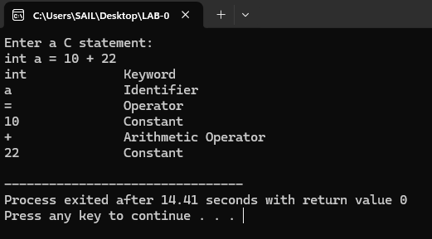

Result :
Thus, the Lexical Analyzer was successfully implemented in C to identify keywords, identifiers, constants, operators, and special symbols from the given C statement.

